**VIVEKANAND EDUCATION SOCIETY’S INSTITUTE OF TECHNOLOGY**

**An Autonomous Institute Affiliated to University of Mumbai**

**Department of Computer Engineering**



Project Report on

DeCAT: Decentralized Certificate Authority

In partial fulfillment of the Fourth Year, Bachelor of Engineering (B.E.) Degree in Computer Engineering at the University of Mumbai Academic Year 2023-24

**Submitted by**

Dhananjay Pai (D17B - 50)

Hrishikesh Patil (D17B - 54)

Varad Deshmukh (D17B - 22)

Yash Sahane (D17B - 60)

**Project Mentor**

Dr.Nupur Giri

(2023-24)

**VIVEKANAND EDUCATION SOCIETY’S INSTITUTE OF TECHNOLOGY**

**An Autonomous Institute Affiliated to University of Mumbai**

**Department of Computer Engineering**



**Certificate**

This is to certify that ***Dhananjay Pai, Hrishikesh Patil, Yash Sahane and Varad Deshmukh*** of Fourth Year Computer Engineering studying under the University of Mumbai have satisfactorily completed the project on “***DeCAT- Decentralized Certificate Authority***” as a part of their coursework of PROJECT-II for Semester-VIII under the guidance of their mentor ***Prof.Nupur Giri*** in the year 2023-24 .

This project report entitled “***DeCAT- Decentralized Certificate Authority***” by ***Dhananjay Pai, Hrishikesh Patil, Yash Sahane and Varad Deshmukh*** is approved for the degree of **Bachelor of Engineering (B.E.) Degree in Computer Engineering** .

| Programme Outcomes | Grade |
| --- | --- |
| PO1,PO2,PO3,PO4,PO5,PO6,PO7,  PO8, PO9, PO10, PO11, PO12  PSO1, PSO2 |  |

Date:

Project Guide:

------------------------------------------

**Project Report Approval**

**For**

**B. E (Computer Engineering)**

This project report entitled **DeCAT: Decentralized Certificate Authority** by ***Dhananjay Pai, Hrishikesh Patil,Yash Sahane and Varad Deshmukh*** is approved for the degree of **Bachelor of Engineering (B.E.) Degree in Computer Engineering**.

Internal Examiner

---------------------------------------------

External Examiner

---------------------------------------------

Head of the Department

-----------------------------------------------

Principal

-----------------------------------------------

Date:

Place:

**Declaration**

We declare that this written submission represents our ideas in our own words and where others' ideas or words have been included, we have adequately cited and referenced the original sources. We also declare that we have adhered to all principles of academic honesty and integrity and have not misrepresented or fabricated or falsified any idea/data/fact/source in our submission. We understand that any violation of the above will be cause for disciplinary action by the Institute and can also evoke penal action from the sources which have thus not been properly cited or from whom proper permission has not been taken when needed.

| -----------------------------------------  (Signature)  -----------------------------------------  Dhananjay Pai (50) | -----------------------------------------  (Signature)  -----------------------------------------  Hrishikesh Patil (54) |
| --- | --- |
| -----------------------------------------  (Signature)  -----------------------------------------  Varad Deshmukh (22) | -----------------------------------------  (Signature)  -----------------------------------------  Yash Sahane (60) |

Date:

**ACKNOWLEDGEMENT**

We are thankful to our college Vivekanand Education Society’s Institute of Technology for considering our project and extending help at all stages needed during our work of collecting information regarding the project.

It gives us immense pleasure to express our deep and sincere gratitude to Professor **Dr.(Mrs.) Nupur Giri** for her kind help and valuable advice during the development of project synopsis and for her guidance and suggestions.

We are deeply indebted to Head of the Computer Department **Dr.(Mrs.) Nupur Giri** and our Principal **Dr. (Mrs.) J.M. Nair ,** for giving us this valuable opportunity to do this project.

We express our hearty thanks to them for their assistance without which it would have been difficult in finishing this project synopsis and project review successfully.

We convey our deep sense of gratitude to all teaching and non-teaching staff for their constant encouragement, support and selfless help throughout the project work. It is great pleasure to acknowledge the help and suggestion, which we received from the Department of Computer Engineering.

We wish to express our profound thanks to all those who helped us in gathering information about the project. Our families too have provided moral support and encouragement several times.

**Computer Engineering Department**

**COURSE OUTCOMES FOR B.E PROJECT**

Learners will be to,

| **Course Outcome** | **Description of the Course Outcome** |
| --- | --- |
| CO 1 | Able to apply the relevant engineering concepts, knowledge and skills towards the project. |
| CO2 | Able to identify, formulate and interpret the various relevant research papers and to determine the problem. |
| CO 3 | Able to apply the engineering concepts towards designing solutions for the problem. |
| CO 4 | Able to interpret the data and datasets to be utilized. |
| CO 5 | Able to create, select and apply appropriate technologies, techniques, resources and tools for the project. |
| CO 6 | Able to apply ethical, professional policies and principles towards societal, environmental, safety and cultural benefit. |
| CO 7 | Able to function effectively as an individual, and as a member of a team, allocating roles with clear lines of responsibility and accountability. |
| CO 8 | Able to write effective reports, design documents and make effective presentations. |
| CO 9 | Able to apply engineering and management principles to the project as a team member. |
| CO 10 | Able to apply the project domain knowledge to sharpen one’s competency. |
| CO 11 | Able to develop a professional, presentational, balanced and structured approach towards project development. |
| CO 12 | Able to adopt skills, languages, environment and platforms for creating innovative solutions for the project. |

**Index**

| **Chapter** | **Title** | **Page no.** |
| --- | --- | --- |
|  | **Abstract** | 10 |
| **1** | **Introduction** | 11 |
| 1.1 | Introduction | 11 |
| 1.2 | Motivation | 12 |
| 1.3 | Problem Definition | 12 |
| 1.4 | Existing Systems | 13 |
| 1.5 | Lacuna of the existing systems | 13 |
| 1.6 | Relevance of the Project | 14 |
| **2** | **Literature Survey** | 15 |
| 2.1 | Brief Overview of Literature Surve | 15 |
| 2.2 | Research Papers Referred | 15 |
| 2.3 | Comparison with the existing system | 20 |
| **3** | **Requirement Gathering for the Proposed System** | 21 |
| 3.1 | Introduction to requirement gathering | 21 |
| 3.2 | Functional Requirements | 21 |
| 3.3 | Non-Functional Requirements | 21 |
| 3.4 | Hardware, Software , Technology and tools utilized | 22 |
| 3.5 | Constraints | 23 |
| **4** | **Proposed Design** | 24 |
| 4.1 | Block diagram of the system | 24 |
| 4.2 | Detailed Design | 25 |
| 4.3 | Project Scheduling & Tracking using Gantt Chart | 26 |
| **5** | **Implementation of the Proposed System** | 27 |
| 5.1 | Methodology employed for development | 27 |
| 5.2 | Algorithms and flowcharts for the respective modules developed | 28 |
| **6** | **Results and Discussion** | 31 |
| 6.1 | Screenshots of User Interface (UI) for the respective module | 31 |
| 6.2 | Performance Evaluation measures and input parameters considered | 36 |
| 6.3 | Graphical and statistical output | 37 |
| **7** | **Conclusion** | 38 |
| 7.1 | Limitations | 38 |
| 7.2 | Conclusion | 38 |
| 7.3 | Future Scope | 39 |
|  | **References** | 40 |
|  | **Appendix** | 42 |
|  | **Achievements** | 42 |
|  | Plagiarism report | 42 |
|  | Paper I | 43 |
|  | Project review sheet | 48 |

# 

## List of Figures :

| **Figure No.** | **Heading** | **Page No**. |
| --- | --- | --- |
| Fig 4.1 | Block diagram | 24 |
| Fig 4.2 | Detailed Design of DeCAT | 25 |
| Fig 4.3 | Gantt Chart | 26 |
| Fig.6.1 | Home Page UI | 31 |
| Fig.6.2 | Minting/Issuance Page | 31 |
| Fig 6.3 | User Portfolio | 32 |
| Fig 6.4 | Verification QR Scanner and Verified Message. | 32 |
| Fig 6.5 | Endorsements by Users | 33 |
| Fig 6.6 | AI-Driven Job Availability Index and Statistics | 33 |
| Fig 6.7 | Reputation score of Users | 34 |
| Fig 6.8 | Leaderboard based on Reputation Scores | 34 |
| Fig 6.9 | Dynamic Job Market Visualization | 37 |

## List of Tables :

| **Figure No.** | **Heading** | **Page No** |
| --- | --- | --- |
| Table 1.1 | Comparison with existing platforms | 13 |
| Table 2.1 | General overview and advantage over existing systems | 20 |
| Table.6.1 | Evaluating the performance for single and bulk minting | 36 |

# Abstract

In the contemporary landscape of credential issuance and verification, a multitude of challenges persist, ranging from the rampant proliferation of duplicated certificates to the threat of document tampering and fraudulent practices, all of which collectively erode trust in the reliability and authenticity of certificates. Addressing these pressing concerns, this research advocates for a paradigm shift in the approach to credential validation through the adoption of blockchain technology.

At the heart of this proposed solution lies the utilization of blockchain, a distributed ledger technology renowned for its immutability and transparency. The proposed system seeks to mitigate the aforementioned challenges by introducing soul-bound tokens (SBTs), which serve as cryptographic representations of individuals' skills and qualifications. SBTs ensure the integrity and authenticity of certificates, thereby instilling confidence in their validity.

Furthermore, the credibility of certificates is further bolstered through an innovative endorsement system, wherein verified certificate holders can publicly affirm the legitimacy of their credentials. These endorsements, prominently displayed within individual portfolios, serve as tangible attestations to the authenticity of certificates, thereby enhancing trust in the system.

To streamline the verification process, the system incorporates QR codes embedded within SBT certificates, allowing for seamless and efficient authentication.

Additionally, an AI-driven Reputation Score mechanism dynamically evaluates individuals' proficiency based on a comprehensive set of parameters, providing a tangible metric for assessing candidates' expertise and credibility.

In summation, this research underscores the transformative potential of the proposed system in revolutionizing credential validation within the market. By offering a transparent, efficient, and trustworthy approach to certificate issuance and authentication, this solution has the capacity to significantly enhance the reliability and integrity of credentials, thereby addressing critical concerns and ushering in a new era of confidence in credential verification.

# Chapter 1 : Introduction

## 1.1 Introduction

In recent years, the landscape of certificates, achievements, and credentials management has encountered significant challenges within various industries and organizations. Traditional methods of issuing and verifying certificates have been plagued by several issues, including duplication, document tampering, malpractices in issuance, and a general lack of trustworthiness.These shortcomings undermine the credibility and value of individuals' accomplishments, leading to skepticism and uncertainty in the validity of their claims. Moreover, the ease with which individuals can falsify their portfolios exacerbates these concerns, further eroding confidence in the integrity of certificates and achievements.

According to the report given in [9], the worldwide certificate authority market is projected to expand at a compound annual growth rate (CAGR) of 12.2% during the period 2022-2030, from its 2021 valuation of USD 127.34 million.A study by L. Ndlovu et.al in [8] discussed the issues like false claims affecting the job market and the law being imposed to minimize the side-effects of these dishonest practices in South Africa. The topic of perceived risk and trust, specifically the nature of purchasing associations among the pricey, sophisticated, high-risk, and credibility items like jewels, was the focus of another research[11].

According to CareerBuilder Survey [10], companies face an average loss of $15,000 for each incorrect hire or for recruiting individuals with fraudulent qualifications. This financial setback is compounded by potential risks to public safety, such as buildings designed by unqualified engineers or medical treatments administered by fake doctors. Properly validating certificates before hiring individuals is crucial to mitigating these risks. However, the challenge lies in the complexity and resource-intensive nature of credential verification, which consumes significant time, money, and organizational resources. As a result, there has been a growing demand for innovative solutions that address these shortcomings and provide a more secure, transparent, and reliable means of managing credentials.

Against this backdrop, initiatives like DeCAT (Decentralized Certificate Authority) have emerged, proposing groundbreaking solutions that harness the potential of blockchain technology and non-fungible tokens (NFTs) to revolutionize the management of certificates and achievements. DeCAT aims to redefine the way certificates are issued, verified, and managed, ensuring the security, integrity, and traceability of each credential.

## 1.2 Motivation

The increasing trend of global mobility in both the education and professional sectors has led to a growing number of individuals pursuing studies and careers abroad. This has consequently placed a heightened importance on the verification of academic and professional credentials by both employers and educational institutions. Simultaneously, students are required to share personal information, including financial details and academic records, with higher education institutions. It is imperative that this information is securely stored, remains unaltered, and can be easily verified. Unfortunately, there is a prevalent issue of individuals falsifying certificates in order to gain employment or admission, posing a significant challenge for organizations in verifying the legitimacy of these documents. In response to these challenges, secure certificate verification systems have been introduced to effectively manage and authenticate certificates.

## 1.3 Problem Definition

The current landscape of issuing and verifying certificates, achievements, and other credentials is plagued by issues such as duplication, editing, and lack of trustworthiness which undermines the value and credibility of prestigious accomplishments. This has led to increased redundancy and lowered the value of prestigious achievements. Additionally, individuals can easily fake their portfolios, leading to a lack of confidence in their claims. These issues not only create redundancy but also erode confidence in individuals' claims and portfolios, leading to an urgent need for a more secure and reliable system.

In light of these challenges, there is a pressing need for a comprehensive solution that addresses the shortcomings of existing credentialing systems. Such a solution should prioritize transparency, security, and accuracy in certificate issuance and verification processes. Additionally, it should incorporate dynamic assessment mechanisms to ensure the relevance and currency of credentials in today's rapidly changing job market. By addressing these key issues, DeCAT aims to revolutionize the credentialing landscape, fostering trust, efficiency, and equity in the recognition of individuals' skills and qualifications by leveraging Soul Bound NFTs

## 1.4 Existing Systems

|  | **Credly** | **Accredible** | **DeCAT** |
| --- | --- | --- | --- |
| Issuance | Uses blockchain to store digital certificates | Uses Bitcoin blockchain to issue digital certificates. | Uses Ethereum and Layer-2 Blockchain (Polygon) to issue certificates as Soul-Bound tokens. |
| Verification | Provides verification through blockchain | Offers verification through secure verification | Provides Verification through blockchain using QR codes |
| Analytics | Provides detailed analytics and insights | Offers analytics on badge engagement | Provides detailed insights and analysis using AI |
| Reputation Mechanism | No such system | No such system | Uses a dynamic reputation scoring system. |

Table 1.1 Comparison with existing platforms.

Table 1.1 demonstrates the comparative study of features provided by various platforms currently present in the certificate industry.

## 

## 1.5 Lacuna of the existing systems

Based on the information provided in the table, the key lacuna or gaps in the existing systems are:

1. Lack of Dynamic Reputation Mechanism: The Credly and Accredible systems do not appear to have a dynamic reputation scoring system in place, which could be a differentiating feature.
2. Limited Blockchain Integration: While Credly and Accredible use blockchain technology for certificate issuance and verification, they do not leverage more advanced blockchain features like those used by DeCAT (Ethereum and Layer-2 Polygon blockchain).
3. Narrow Scope of Blockchain Utilization: The existing systems seem to primarily use blockchain for certificate issuance and verification, without exploring other potential blockchain-based applications or capabilities.
4. Absence of AI-powered Analytics: Credly and Accredible do not appear to offer the same level of detailed insights and analysis powered by AI that DeCAT provides.
5. Restricted Token Offerings: Credly and Accredible are limited to issuing traditional digital certificates, while DeCAT offers the ability to issue Soul-Bound tokens, which could have additional functionalities and use cases.

## 1.6 Relevance of the Project

DeCAT's solution relies on Soul Bound NFTs, unique tokens ensuring certificate authenticity via blockchain. These NFTs cannot be tampered with, mitigating forgery risks. Leveraging blockchain, DeCAT provides a decentralized platform offering transparency and immutability, addressing flaws in traditional certificate management. Notably, DeCAT executes transactions in multi-batch fashion, reducing costs by 99.8% and utilizing a scalable Layer-2 architecture for increased efficiency over Ethereum. Its decentralized application facilitates profile creation, aiding recruitment by ensuring reliable credential verification, fostering community growth, and incentivization.

# **Chapter 2: Literature Survey**

## 

## 2.1. Brief Overview of Literature Survey

The literature survey reveals several innovative approaches to secure certificate verification and credential management systems. One system involves a web application enabling universities to upload or generate certificates, which are stored on IPFS (InterPlanetary File System) in a decentralized and encrypted manner. Another system, known as SBTCERT, implements a similar approach with a decentralized credential recovery mechanism for users who lose their private keys. BeCertify utilizes a peer-to-peer distributed network to transfer higher education degrees onto a blockchain, ensuring secure and efficient storage and exchange of academic qualifications. Additionally, a proposed government-owned private blockchain allows universities, students, and third parties to register and obtain private keys, with tokens for third parties stored on the blockchain. Further innovations include e-certificates with QR codes issued to graduates, providing them with inquiry numbers and electronic certificate files. NFTCert introduces a framework utilizing Non-Fungible Tokens (NFTs) and blockchain technology for digital certificates, along with an online payment gateway to facilitate transactions without relying on cryptocurrency. These advancements showcase diverse approaches to leveraging blockchain and decentralized technologies for secure and efficient certificate verification and credential management.

Our work through DeCAT proposes to address the shortcomings that exist in the market of certification. The issues like duplication, editing and malpractices in the issuance of certificates, can be resolved by leveraging the potential of blockchain technology and introducing the identity token concept using SoulBound token in order to preserve the authenticity and security of the certificate against outside interference. The platform is a one stop solution for all the academic and professional needs and also serves as an individual’s portfolio and increases potential participation to better oneself for better ranking in the domain through platform’s gamification algorithms.

## 2.2 Research Papers Referred

### 1.Tumati, Tarun Vihar. "SBTCERT: A SOULBOUND TOKEN CERTIFICATE VERIFICATION SYSTEM." PhD diss., CALIFORNIA STATE UNIVERSITY, NORTHRIDGE, 2023.

**a. Abstract:** The SBTCERT system, developed by Tarun Vihar Tumati, is a blockchain-based digital certificate platform designed to revolutionize the verification process for educational certificates. Traditional certificate authentication processes are often cumbersome and prone to human error, leading to potential acceptance of fabricated documents. To address these challenges, SBTCERT leverages blockchain technology to create a secure, decentralized, and tamper-proof environment for certificate verification. By hosting certificates on a blockchain network, the system ensures data integrity, transparency, and enhanced security without compromising authentication or confidentiality. Through the implementation of the Soul Bound Token (SBT) and the EIP4973 standard, SBTCERT aims to prevent the issuance of fake or illegal certificates, thereby safeguarding the credibility of both certificate holders and issuing authorities.

**b. Inference drawn:** The SBTCERT system leverages blockchain technology to address limitations in traditional certificate verification. By combining blockchain, IPFS, and smart contracts, SBTCERT offers a secure and tamper-proof solution. This decentralized platform enhances efficiency and transparency for universities, students, and other stakeholders involved in the verification process. The system also ensures data integrity through blockchain recording, preventing unauthorized modifications to certificates. SBTCERT's user-friendly design with simplified signup and multi-factor authentication ensures a seamless user experience. Additionally, the system is designed for future advancements with planned improvements in token standardization, real-time payment processing, auto-scaling, and enhanced security measures. Overall, SBTCERT presents a significant step forward in secure, efficient, and decentralized certificate verification.

### 2.Shrivastava, Ajay Kumar, Chetan Vashistth, Akash Rajak, and Arun Kumar Tripathi. "A decentralized way to store and authenticate educational documents on private blockchain." In 2019 International Conference on Issues and Challenges in Intelligent Computing Techniques (ICICT), vol. 1, pp. 1-6. IEEE, 2019.

**a.Abstract:**The research paper focuses on the utilization of blockchain technology for document verification to enhance security and transparency. It discusses the challenges posed by document forgeries and the need for effective verification systems. The paper explores the use of decentralized online applications, Ethereum blockchain, peer-to-peer storage, and cryptography to quickly and transparently verify documents. Additionally, it proposes the use of private blockchains for storing and verifying academic documents, highlighting the benefits of blockchain technology in improving security, speed, and real-time auditing. The study emphasizes the potential of blockchain in various industries, including education, supply chains, healthcare, and banking, to validate documents and mitigate forgery risks.

**b.Inference:**Blockchain technology is poised to transform document verification. It provides a secure and decentralized solution, eliminating concerns about document fraud, unauthorized modifications, and access. Integrating blockchain creates tamper-proof records of document transactions, boosting security, transparency, and reliability. Smart contracts automate verification using cryptography and digital identifiers, streamlining the process and reducing manual work. This technology can be applied across government, education, and business to improve efficiency in issuing and verifying official documents. Additionally, organizations can leverage blockchain for secure document exchange, data privacy, and decentralized control, strengthening cloud storage security. Overall, blockchain offers a robust and reliable solution for document verification, combating fraud and enhancing security and transparency in digital transactions.

### 3.Zhao, Xiongfei, and Yain-Whar Si. "NFTCert: NFT-based certificates with online payment gateway." In 2021 IEEE International Conference on Blockchain (Blockchain), pp. 538-543. IEEE, 2021.

**a.Abstract:—**Nowadays, academic certificates are still widely issued in paper format. Traditional certificate verification is a lengthy, manually intensive, and sometimes expensive process. In this paper, we propose a novel NFT-based certificate framework called NFTCert, which enables the establishment of links between a legitimate certificate and its owner through a Blockchain. In this paper, we describe the implementation of the NFTCert framework, including schema definition, minting, verification, and revocation of NFT-based certificates. We also introduce a payment gateway into the minting process, which enables NFTCert to be used by a wider audience. Therefore, participants of NFTCerts do not need to rely on cryptocurrency for transactions. All in all, the proposed framework is designed to achieve usability, authenticity, confidentiality, transparency, and availability properties when it is compared to existing Blockchain based systems.

**b.Inference:**The paper introduces NFTCert, a framework utilizing NFTs and blockchain to create secure and verifiable digital academic certificates. It aims to streamline the verification process compared to existing blockchain-based systems like Blockcerts and EduCTX. NFTCert leverages NFTs on the Ethereum blockchain along with smart contracts. Notably, it integrates an online payment gateway to avoid reliance on cryptocurrency for transactions. The overall benefits of NFTCert include tamper-proof certificates, simplified verification, and a decentralized system for managing academic credentials.

### 4.Reddy, Siddhant, and Dharmender Singh Kushwaha. "Framework for privacy preserving credential issuance and verification system using soulbound token." In ITM Web of Conferences, vol. 56, p. 06002. EDP Sciences, 2023.

**a.Abstract:** This paper proposes a framework for privacy-preserving credential issuance and verification over the public blockchain. The credential used in this framework is a soulbound token (SBT), a non-transferable non-fungible token (NFT) verifiable on the blockchain. Once

the issuing organization issues the credential, this framework gives the holder complete control of the credential. This privacy-preserving property allows the holder to selectively disclose the credential attributes in the verification process. The framework proposed suggests a decentralized

credential recovery mechanism if the credential holder loses their private key. This paper compares this framework's efficiency with different schemes based on privacy-preserving, selective disclosure, and decentralized credential recovery. This paper also compares the overhead for credential

issuance and verification with Merkle trees. This paper also discusses the real-world use cases where this framework can be applied.

**b.Inference**:A new framework utilizes blockchain technology and soulbound tokens to create a secure and tamper-proof system for managing credentials. This approach offers several advantages: enhanced security against fraud, decentralized verification reducing reliance on central authorities, and selective disclosure for user privacy control. Additionally, real-time verification allows for faster and more informed decisions. The framework has potential applications across various industries, and the project explores incorporating social recovery mechanisms and further improving privacy features. Overall, this framework highlights the potential of blockchain and soulbound tokens to revolutionize credential management with a secure, efficient, and privacy-focused approach.

### 5.Lim, Joe Onn, and Diyana Kamarudin. "NON-FUNGIBLE TOKENS: ITS POTENTIAL ROLE IN COMBATING CERTIFICATE FRAUDULENCE IN MALAYSIAN EDUCATION." International Journal of Entrepreneurship, Business and Technology 1, no. 1 (2023).

**a.Abstract:** Non-Fungible Tokens (NFT) are blockchain-based tokens representing a particular asset, such as a piece of media or digital data. A digital or physical asset can have an NFT as an irrevocable certificate of ownership and authenticity (Wanget al., 2021). Digital forms of certifications can consider using NFT and blockchain technology (Franceschet, 2021). Technological advancement enabled people to create fraud certificates, such as university degrees,that the buyers do not possess. This is unethical and alarming. The current credentials from certificates are difficult to verify as legitimate, which encourages educational fraud. Blockchain technology with NFTs empowers a solution to certificate fraudulence. Thisstudyscrutinizesthe demand of a handful of Malaysians towards buying fraud certificates and the ideas behind those supplying such certificates.Potential use cases and challenges on how NFTs can combat certificate fraudulence and enhance education systems are studied by gathering information from past literature and conducting interviews with people involved in certification fraud. The ethnography approach focuses on the occurrence of fake certificates in society that consists of using certificates to seek employment or income permits. Convenience sampling is applied to assess respondents' perspectives, who are also aware of NFT technology. The lack of coordination in Malaysia between multiple parties,such as certificate issuers, companies hiring employees and government authorities,allows certification fraud to occur. An increase inNFT public penetration and blockchain technology can counter this issue.

**b.Inference:** This study examines certificate fraud in Malaysia's education system and proposes NFTs and blockchain technology as potential solutions. The research explores the negative impacts of fake certificates, including a decrease in the value of genuine credentials. It aims to understand why people buy and sell fake certificates, and then assess how NFTs and blockchain can be used to prevent this fraud. By utilizing the secure and decentralized nature of blockchain, the study hopes to revolutionize how educational credentials are verified and increase trust in certificates. Overall, this project contributes to discussions about using new technologies to fight fraud and protect the integrity of educational qualifications in Malaysia.

### 6.Alonso, Cristian, Tanuj Bhojwani, Emine Hanedar, Dinar Prihardini, Gerardo Uña, and Kateryna Zhabska. Stacking up the benefits: Lessons from India’s digital journey. International Monetary Fund, 2023.

**a.Abstract:**Foundational digital public infrastructure (DPI), consisting of a unique digital identification, payments system and data exchange layer has the potential to support the transformation of the economy and support inclusive growth. India’s foundational DPI, called India Stack, has been harnessed to foster innovation and competition, expand markets, close gaps in financial inclusion, boost government revenue collection and improve public expenditure efficiency. India’s journey in developing a world-class DPI highlights powerful lessons for other countries embarking on their own digital transformation, in particular a design approach that focuses on shared building blocks and supporting innovation across the ecosystem.

**b.Inference:**India's experience with digital transformation offers valuable lessons for other nations. Research shows their Digital Public Infrastructure (DPI) approach has significantly advanced development goals. While Aadhaar, a unique government ID system, is a noteworthy feature, it's not essential for digital success. There's still room for improvement in digital access for all Indians. However, their world-class DPI has demonstrably supported sustainable development and innovation across sectors. Furthermore, it has streamlined government operations, enabling efficient benefit transfers and revenue collection. Overall, India's digital journey highlights the transformative power of technology and offers a roadmap for countries pursuing similar goals.

## 2.3 Comparison with the existing system

| Other systems | DeCAT |
| --- | --- |
| Uses centralized database or Layer 1 Blockchain | Uses Layer 2 Blockchain such as polygon |
| Provides overview of certificates issued | Provides detailed analytics about the issued certificates |
| No Reputation Mechanism | AI-Driven reputation system built |

Table 2.1 General overview and advantage over existing systems

# 

# 

# 

# 

# 

# 

# Chapter 3: Requirement Gathering for the Proposed System

## 3.1 Introduction to requirement gathering

The Requirement Gathering is a process of requirements discovery or generating list of requirements or collecting as many requirements as possible by end users. It is also called as requirements elicitation or requirement capture.

The requirements gathering process consists of five steps :

* Identify the relevant stakeholders
* Establish project goals and objectives
* Elicit requirements from stakeholders
* Document the requirements
* Confirm the requirements

## 3.2 Functional Requirements

1. User Authentication and Identity Verification:

* Users must be able to authenticate themselves securely using credentials login adhaar login.

2. Issuer Dashboard:

* The dashboard must allow issuers to input details about the Soul Bound Tokens (SBTs), including metadata, achievements, and other relevant information. It should also support importing a CSV dataset for efficient bulk transactions.

3. SBT Minting:

* Issuers, upon successful verification, should be able to create SBTs by entering relevant details. The system must support bulk transactions to efficiently send SBTs to a large number of recipients in a single transaction.

4. Verification Check:

* Each SBT should have a unique identifier (QR Code), for anyone to verify the legitimacy of a token by checking its origin and confirming its validity on the blockchain.

## 3.3 Non-Functional Requirements

* Scalability: The platform should be designed to handle large numbers of users, music tracks, and transactions. It should be able to scale up or down as needed to meet demand.
* Security: The platform should be built with robust security measures to prevent hacking, fraud, and other cyber threats. It should also protect user data privacy..
* Interoperability: The platform should be interoperable with other blockchain-based systems, allowing for seamless integration and data sharing.
* Usability: The platform should be easy to use and intuitive, with a user-friendly interface that allows users to navigate the system and perform tasks without difficulty.
* Compliance: The platform should comply with relevant legal and regulatory requirements, such as copyright laws and anti-money laundering regulations.

## 3.4. Hardware, Software , Technology and tools utilized

### Hardware :

* Blockchain Node:
  + Processor: Multi-core processor
  + RAM: 4 GB or higher
* Load Balancer (for scalability):
  + Processor: Multi-core processor
  + RAM: 4 GB or higher

### Software :

* Blockchain Software:
  + Smart Contract Development: Solidity programming language
  + Web3 Libraries: Web3.js or ethers.js
  + Tools : Anon-Aadhaar , OpenSea
* Backend Framework:
  + Node.js: For server-side JavaScript runtime
  + Express.js: Web application framework for Node.js
* Frontend Framework:
  + React.js : For building dynamic user interfaces
* Smart Contract Deployment and Testing:
  + Truffle or Hardhat: Frameworks for deploying and testing smart contracts

AI : Gemini Pro LLM model.

## 3.5 Constraints

Blockchain Scalability:

* + Description: Blockchain networks, including Ethereum, may face scalability issues, leading to delays in transaction processing and higher fees during periods of network congestion.
  + Mitigation: Utilize scaling solutions, such as layer-2 solutions like rollups, to enhance the scalability of the application.
* Smart Contract Security:
  + Description: Smart contracts are susceptible to vulnerabilities, and security audits are crucial to identifying and addressing potential issues.
  + Mitigation: Regularly audit smart contracts using tools like MythX and engage with professional auditing services.
* Ethereum Gas Fees:
  + Description: Transaction fees (gas fees) on the Ethereum network can be unpredictable and may become expensive during periods of high demand.
  + Mitigation: Consider implementing gas optimization strategies and explore alternative blockchains or layer-2 solutions to mitigate high gas fees.

Third-Party Dependencies:

* Description: Reliance on third-party services or tools may introduce dependencies that are beyond the project team's control.
* Mitigation: Choose reputable and well-supported third-party services, have contingency plans for potential service disruptions, and consider decentralized alternatives where possible.

# **Chapter** 4**: Proposed Design**

## 4.1 Block diagram of the system

Fig 4.1 Block diagram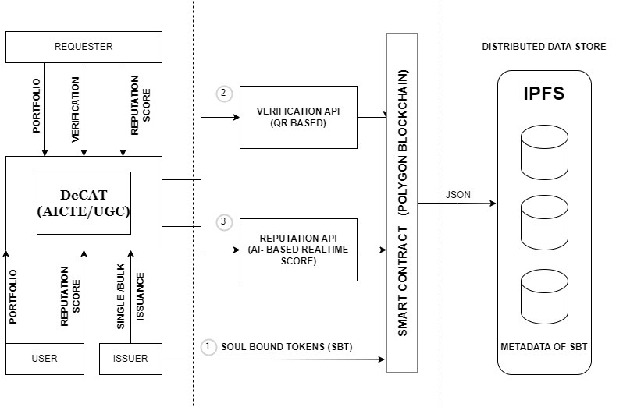

The project proposes a secure, transparent credentialing system using Soul Bound Tokens (SBTs). Only whitelisted organizations can issue SBTs for achievements like patents and grants. Users can manage their SBT portfolio and verify SBT authenticity using QR codes. The platform enables peer endorsements and implements an AI-driven reputation scoring model that considers both SBT holdings and real-time job market demands. This incentivizes users to acquire high-value skills and provides HR managers with a reliable candidate assessment tool. By addressing transparency, duplication, and misalignment issues, the project represents an innovative solution for the future of professional certifications.

The overall flow of the system as depicted in Fig 4.1 is as follows:

1. The requester interacts with the DeCat (AICTE/UGC) module, which then communicates with the Verification API and Reputation API.
2. The Verification API performs the QR-code-based verification process using the Soul Bound Tokens provided by the requester.
3. The Reputation API calculates the real-time reputation score for the requester based on the AI-powered analysis.
4. The DeCAT module receives the verification status and reputation score from the respective APIs and processes the request accordingly.
5. The metadata associated with the Soul Bound Tokens is stored in the Distributed Data Store (IPFS) for future reference and accessibility.

This architecture aims to provide a decentralized and secure mechanism for verifying the identity and reputation of users or entities within the system, leveraging the use of Soul Bound Tokens and AI-powered reputation analysis.

## 4.2 Detailed Design

Fig 4.2 Detailed Design of DeCAT

The above Fig 4.2 details the following :

This decentralized application architecture consists of several key components. The Frontend Service provides a React-based user interface that interacts with the API Service, which exposes endpoints via FastAPI to handle request and response cycles. The Credential Verification and Insights module is responsible for verifying user credentials and generating insights from web3 data. The Issuance (Minting) module handles the minting or issuance of assets. The IPFS Metadata Store is a decentralized storage system for application metadata. The application leverages the Polygon Mainnet, a layer-2 scaling solution, to provide faster transactions and lower costs. The ERC5192 Smart Contract implements the Soul Bound Properties feature, which represents non-transferable Soul Bound Tokens (SBTs). Finally, the ERC721 Smart Contract, built using the Open Zeppelin library, handles the management of non-fungible tokens (NFTs) within the system.

## 4.3 Project Scheduling & Tracking using Timeline / Gantt Chart :

The Gantt chart of our project where we worked for the whole semester to create this model is shown in a timeline pattern. It is the most important part to think and design the planning of your topic and so we planned our work like the gantt chart shown.

Fig 4.3 Gantt Chart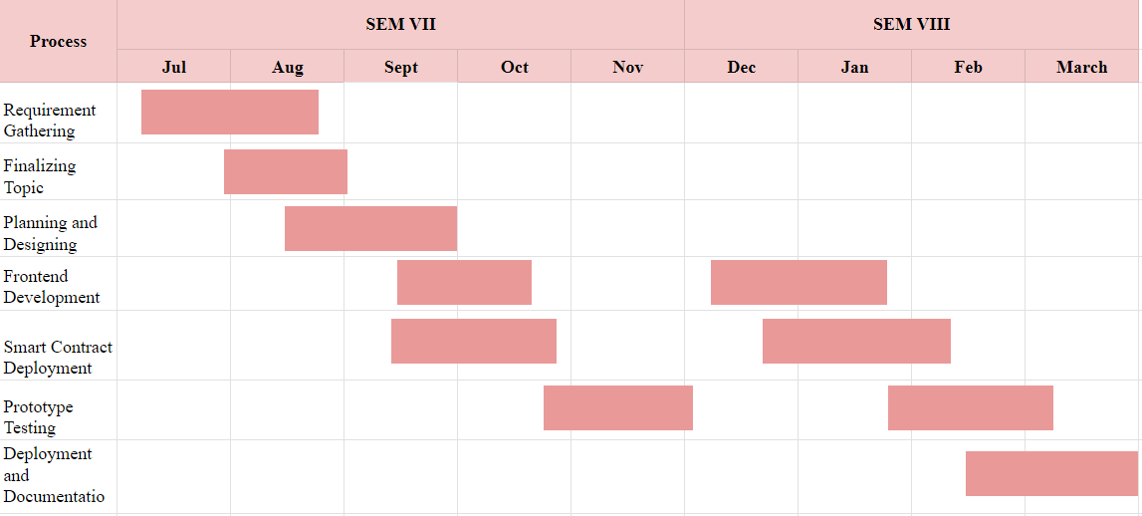

# Chapter 5: Implementation of the Proposed System

## 

## 5.1. Methodology employed for development

Detailed Methodology for Development:

**1. Research and Requirement Gathering:**

* Conduct extensive research on existing credentialing systems, blockchain technology, and AI-based reputation scoring mechanisms.
* Gather requirements through stakeholder interviews, surveys, and market analysis to understand user needs and industry trends.

**2. System Design and Architecture:**

* Design the system architecture, including the database schema, application logic, and user interface.
* Define the data models for SBTs, user profiles, endorsements, and reputation scores.
* Select appropriate blockchain platform and smart contract framework for issuing and managing SBTs.

**3. Frontend and Backend Development:**

* Develop the frontend of the platform using modern web technologies such as HTML, CSS, and JavaScript.
* Implement responsive design principles to ensure usability across devices and screen sizes.
* Build the backend infrastructure using frameworks like Node.js or Django, integrating with the selected blockchain platform for SBT issuance and verification.

**4. Smart Contract Development:**

* Write smart contracts for SBT issuance, endorsement, and verification using Solidity or other compatible languages.
* Implement access control mechanisms to restrict SBT issuance to whitelisted organizations and ensure data integrity on the blockchain.

**5. Integration of Verification Module:**

* Integrate QR code generation functionality into the platform for generating proof of SBT authenticity.
* Develop a verification module to validate SBTs using the generated QR codes, leveraging libraries like ZXing or jsQR.

**6. Portfolio Development:**

* Design and implement the portfolio feature to allow users to manage and showcase their collection of SBTs.
* Enable search functionality to allow users to discover and explore other users' SBTs based on various criteria.

**7. Endorsement System Implementation:**

* Design and implement the endorsement system to enable users to endorse each other for different skills and achievements.
* Define rules and guidelines for endorsing others to prevent misuse and maintain integrity.

**8. AI-Based Reputation Module Integration:**

* Develop algorithms to calculate reputation scores for users based on parameters such as the number of SBTs owned, endorsements given and received, and AI-derived job availability index.
* Integrate web crawlers or APIs to gather real-time job availability data for different skills.
* Implement dynamic weighting mechanisms to adjust reputation scores based on market demand and user activity.

## 5.2 Algorithms and flowcharts for the respective modules developed

The system operates seamlessly through a series of intuitive steps, beginning with authorized personnel from organizations logging into the platform to distribute Soulbound Tokens (SBTs) via the issuance module. Once distributed, these SBTs can be easily verified using a QR scanner generated during the minting process, with the verification module cross-referencing blockchain data for immutability. Simultaneously, the certificate can be utilized to calculate the reputation of the profile, dynamically assessing its value through the proprietary model. This reputation score is then translated into a user-friendly dashboard, empowering recruiters to identify candidates who meet their requirements based on authentic certificate claims. This streamlined flow ensures efficiency and reliability throughout the credential verification and recruitment processes, enhancing transparency and trust in the platform. The in-depth implementation of the respective modules are as follows:

1. **Certificate Issuance Module:**

Certificate issuance on the platform is facilitated by authorized personnel from respective organizations upon logging into the system. These credentials are securely whitelisted into the platform, ensuring a safe interaction environment. Following authentication, the entity is prompted to input certificate metadata such as title, image, description, and subject for certification purposes. Deployed on Ethereum and Polygon blockchains, the system adheres to the EIP5192 and ERC 721 standards, outlining the structure for Soul Bound Tokens (SBTs). Supporting both single mint and multi-batch mint functionalities, the platform enables individual SBT creation and efficient bulk minting through multi-batch transactions, as illustrated in Figure 1 and detailed in Table 2, respectively. The immutability of certificates ensures credibility, as they cannot be burned or transferred further to other users. Subsequently, issued certificates are stored on the InterPlanetary File System (IPFS) using Lighthouse.storage, a decentralized storage solution. Candidates can access their certificates through their respective public wallet addresses on the platform or via marketplaces like OpenSea.

1. **Verification Module:**

A prominent feature of the platform is its robust method of certificate issuance, aimed at mitigating issues such as duplication and fraudulent practices prevalent in the market. This credibility is underscored by the platform's verification module, which generates a unique QR code for each minted certificate. This QR code serves as a reliable method for verifying the authenticity of the certificate. Users can simply scan the QR code using their devices, which redirects them to the platform's website. Here, the certificate's metadata, including minting hash, title, description, and other relevant details, are displayed, allowing for real-time verification of its authenticity. This process ensures transparency and reliability by cross-checking the data stored on the blockchain.

1. **Profile Reputation Score Module:**

The flagship feature of the platform revolves around scoring user profiles based on their earned certificates, reflecting the skills acquired by individuals. This scoring mechanism considers not only the number of certificates but also incorporates market conditions and endorsements from other entities. Endorsements are restricted by the number of certificates held by the endorsing entity. The proprietary dynamic reputation scoring algorithm assesses certificates relative to market response and value, leveraging live job market statistics obtained through autonomous agents powered by LLM technology. These agents gather real-time job demographics, assigning normalized weights to certificates for profile score calculation.

Integration of reputation scores into user profiles enables individuals to showcase their proficiency and credibility within the job market ecosystem. The transparent and auditable score calculation process records all relevant data and transactions on the blockchain, ensuring reliability and accountability. Designed for scalability, the feature efficiently handles a large volume of users and transactions, employing responsive and accurate algorithms within the smart contract.

The calculated scores are prominently displayed on a platform leaderboard, highlighting top users with the most acquired skills. This leaderboard fosters a competitive learning environment, encouraging increased user interaction with the platform. Additionally, the platform utilizes Generative AI, specifically Gemini Pro LLM, to streamline candidate shortlisting processes for recruiting entities. By compiling certification data associated with user wallet addresses into easily readable formats, the system offers comprehensive insights into individual achievements. Leveraging Generative AI enhances the hiring and job-seeking process, making it easier, transparent, and trustworthy for all involved parties.

# Chapter 6: Results and Discussion

## 

## 6.1. Screenshots of User Interface (UI) for the respective module

Fig.6.1 Home Page UI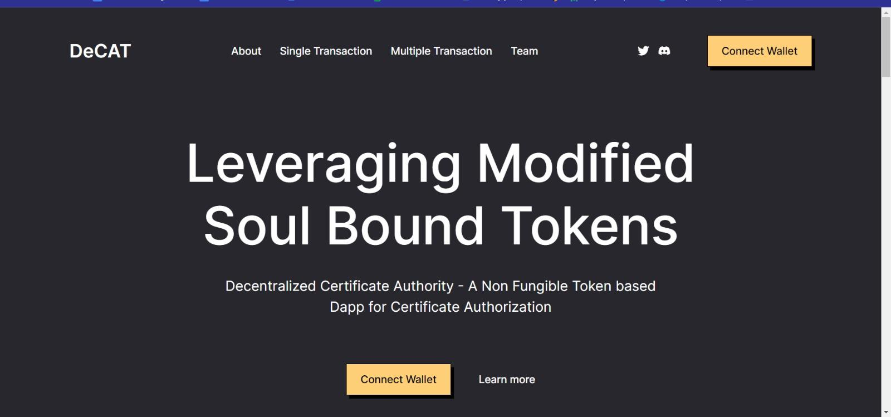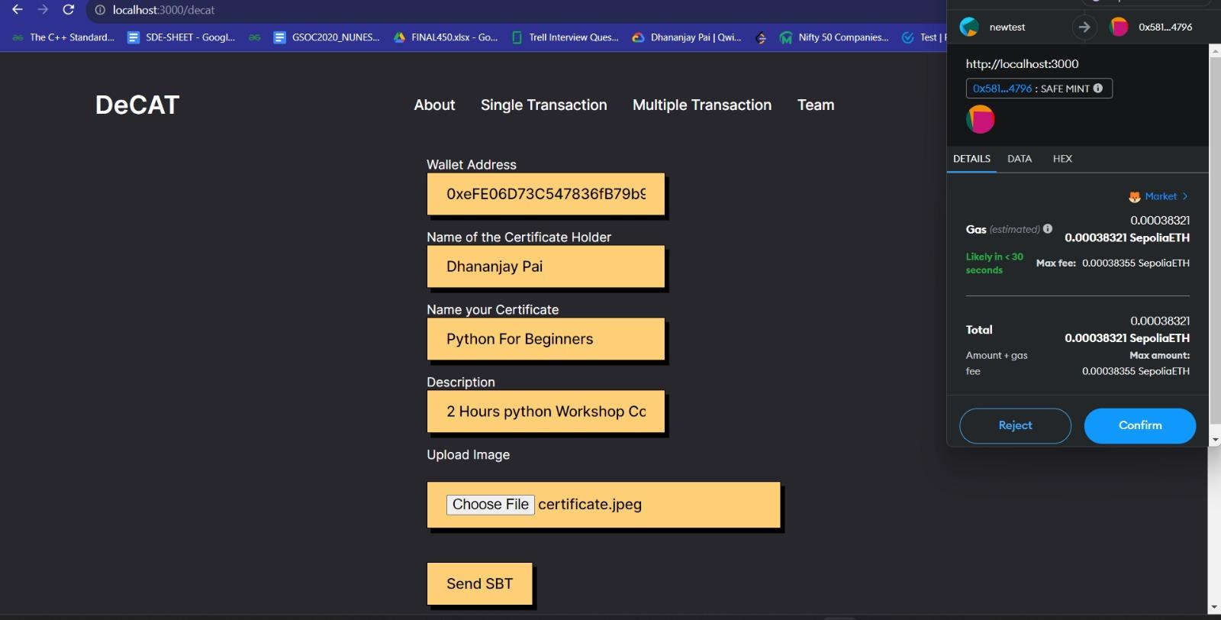

Fig 6.2 Minting/Issuance Page

Fig 6.3 User Portfolio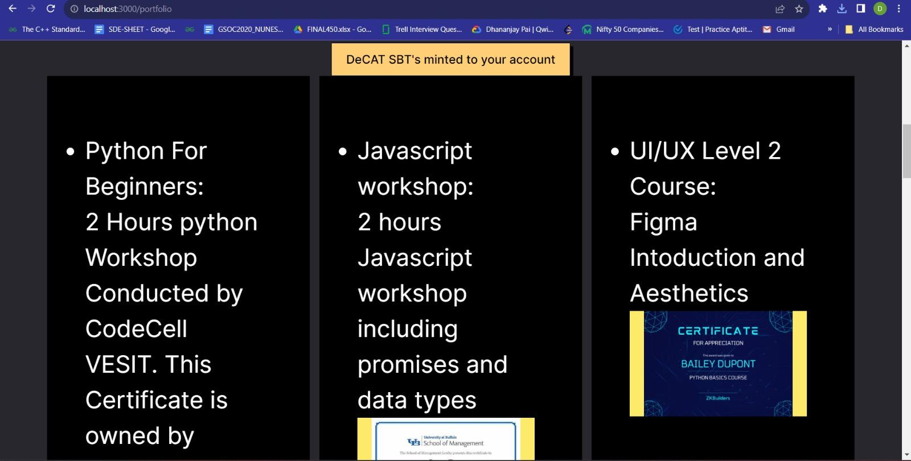

Fig 6.4 Verification QR Scanner and Verified Message.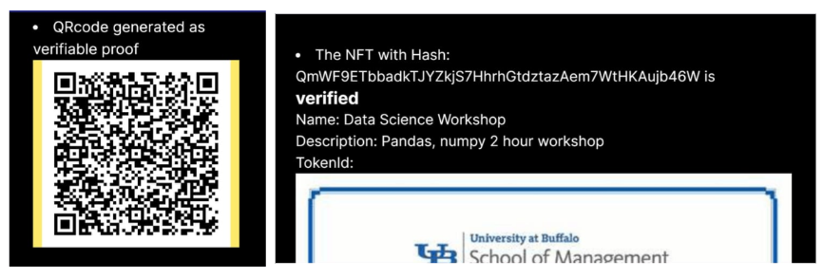

Fig 6.5 Endorsements by Users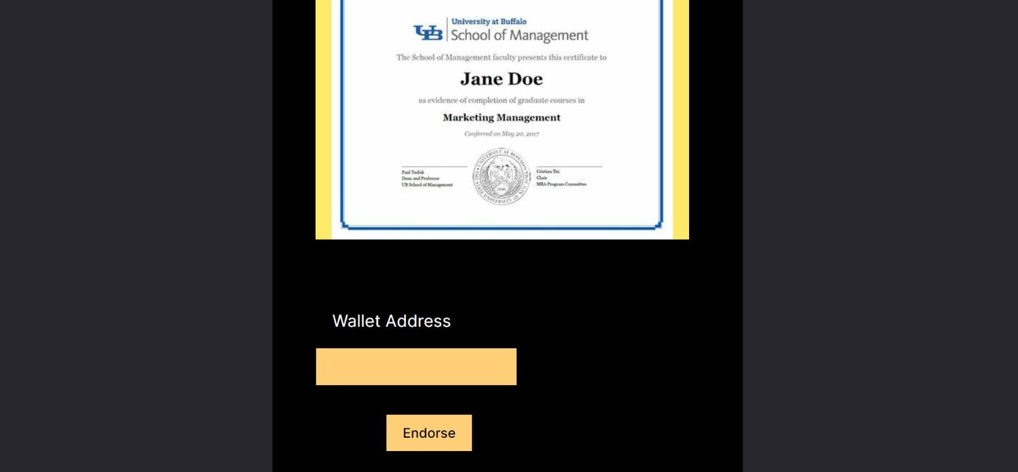

Fig 6.6. AI-Driven Job Availability Index and Statistics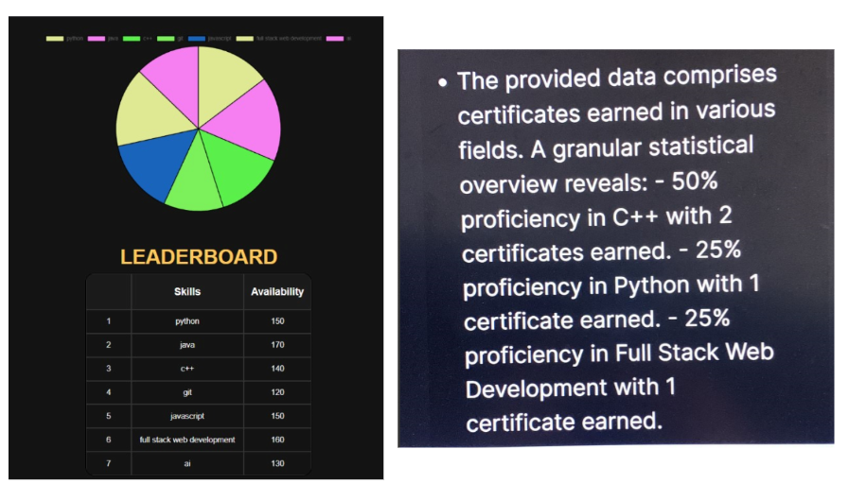

Fig 6.7. Reputation score of Users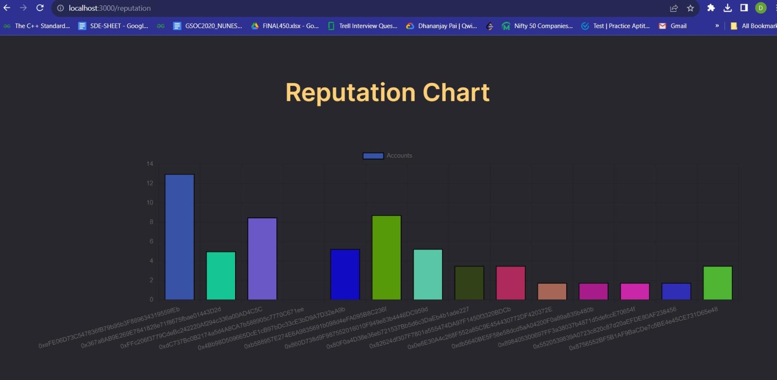

Fig 6.8. Leaderboard based on Reputation Scores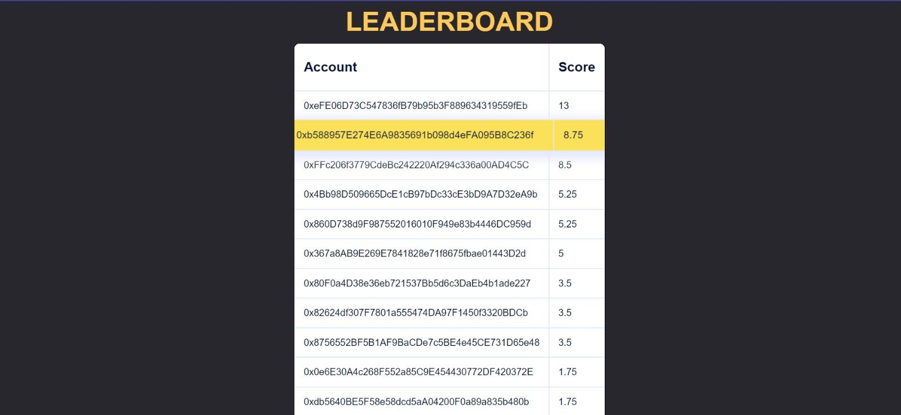

**Home Page:** The home page features a sleek and intuitive design as depicted in Fig 6.1, with easy navigation and prominent sections highlighting key project features such as SBT issuance, portfolio management, QR code verification, endorsements, and the AI-based Reputation Module. Users are greeted with a visually appealing interface that provides a clear overview of the platform's capabilities, encouraging exploration and engagement.

**Minting Module:** The minting module as seen in Fig 6.2. offers a user-friendly interface for whitelisted organizations to seamlessly issue Soul Bound Tokens (SBTs). With options for both individual and bulk minting, organizations can efficiently upload CSV files containing pertinent details like addresses and descriptions, facilitating smooth multi-batch transactions. The module streamlines the issuance process, ensuring organizations can easily manage and distribute SBTs while maintaining transparency and authenticity.

**Verification Module:** A pivotal aspect of the platform's credibility-enhancing features lies in its implementation of FAST API and openCV technology. Leveraging FAST API, the platform seamlessly generates unique QR codes with each minted certificate as shown in Fig 6.4. , ensuring a swift and efficient process. This integration not only streamlines certificate verification but also enhances user experience by providing a reliable method for confirming authenticity. Furthermore, the utilization of openCV, a powerful library for real-time computer vision, underscores the platform's commitment to cutting-edge technology. By harnessing openCV, the system is equipped to handle complex image processing tasks associated with QR code scanning, ensuring accurate and reliable verification of certificate details stored on the blockchain. Together, these technologies bolster the platform's credibility and reliability, providing users with a seamless and trustworthy experience in the verification process.

**Reputation Score Module:** Fig 6.6, Fig 6.7 and Fig 6.8 collectively represent the reputation score module which provides a comprehensive evaluation of users' expertise and credibility within the platform. Leveraging AI-driven algorithms and real-time job availability data, it dynamically generates reputation scores based on factors such as the number of SBTs owned, endorsements received, and skills in demand. This innovative feature not only authenticates users' proficiency across various domains but also assists hiring managers in identifying top talent by offering a reliable metric for assessing skills and qualifications.

## 6.2. Performance Evaluation measures and input parameters considered.

The platform meticulously analyzed performance metrics, focusing on time efficiency and gas fees for minting on layer 2 blockchain. Certificate details, consistent across single and bulk minting, were rigorously tested, varying bulk file sizes for comprehensive analytics. Single mint transactions demonstrated swift issuance of Soul Bound Tokens (SBTs) with minimal overhead. Bulk minting operations scaled efficiently, ensuring organizations manage issuance without compromising speed or affordability. Overall, the platform's optimization efforts guarantee a seamless user experience while upholding transparency and cost-efficiency in SBT issuance. The statistics are as mentioned in Table.3.

Table.6.1. Evaluating the performance for single and bulk minting.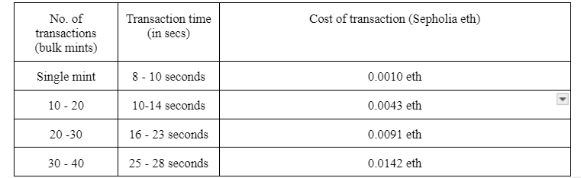

## 

## 6.3. Graphical and statistical output

Fig.6.9. Dynamic Job Market Visualization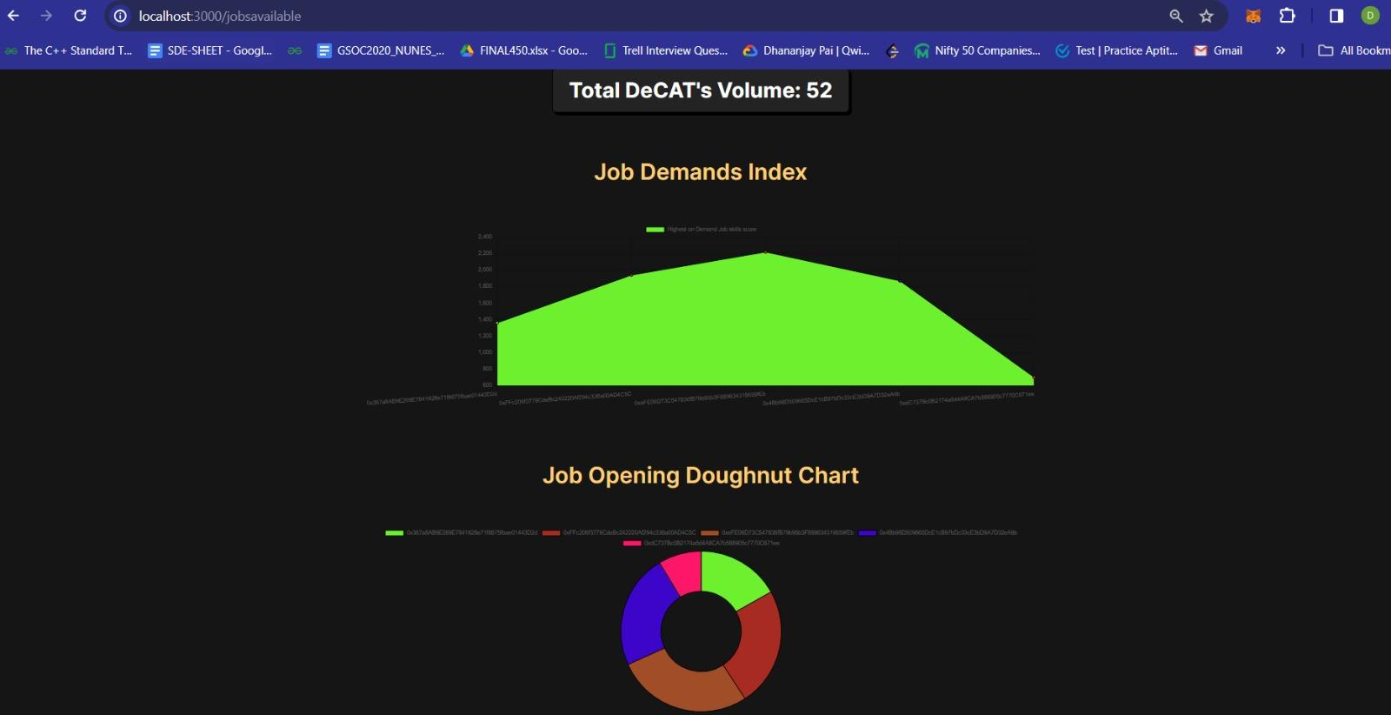

The displayed graph provides real-time insights into the current job market availability, offering users a comprehensive understanding of the demand for specific skills. This dynamic feature serves as a valuable resource for individuals seeking to enhance their professional profiles, enabling them to align their skill development efforts with the ever-evolving job market landscape. Leveraging cutting-edge technology, the platform dynamically fetches and analyzes job market data, ensuring that users receive accurate and up-to-date information to inform their career decisions. By incorporating this real-time job availability data into the scoring mechanism, the platform facilitates a more nuanced assessment of users' profiles, enhancing the relevance and reliability of their reputation scores. Ultimately, this innovative approach empowers users to make informed choices regarding skill acquisition and career development, maximizing their opportunities for success in the competitive job market.

## 

# Chapter 7: Conclusion

## 7.1 Limitations

### Transition to Web3 Platform :

The transition from a Web2 platform to a Web3 platform built on blockchain technology presents several challenges. Users may find it difficult to adapt to the decentralized nature of the platform and the associated concepts such as digital wallets and smart contracts. This learning curve, coupled with the infrastructure requirements of accessing Web3 platforms, poses significant barriers to adoption.

### Dependency on Wallets:

Furthermore, requiring users to have digital wallets like MetaMask or Coinbase adds another layer of complexity. Not only does this create obstacles for individuals who lack familiarity with cryptocurrency technology, but it also raises concerns about security and dependency on third-party services. Users need to understand how to secure their wallets to avoid risks such as phishing attacks and unauthorized access.

Addressing these challenges will require comprehensive user education, simplification of processes, and enhanced security measures to facilitate the transition to a Web3 platform seamlessly.

## 7.2 Conclusion

The project represents a groundbreaking leap forward in leveraging blockchain technology to revolutionize the landscape of professional credentialing. By introducing Soul Bound Tokens (SBTs), the platform offers individuals an unprecedented level of security and immutability in storing and presenting their certifications. Through the use of QR code verification, the authenticity and dependability of these credentials are seamlessly confirmed, instilling greater confidence and trust among users. Moreover, the platform's endorsement system serves to reinforce users' trust networks by providing a mechanism for the validation of skills, based on the rich metadata associated with SBTs.

At the core of the project lies the innovative Reputation Score mechanism, which dynamically evaluates and reflects individuals' expertise across various domains. This not only serves to authenticate individuals' proficiency but also empowers hiring managers to make well-informed decisions when seeking out top-tier talent. By streamlining and enhancing identity verification and credentialing processes, the project showcases the transformative potential of blockchain technology within the realm of employment.

The integration of an EIP5192-compatible Decentralized Certification Authority and Reputation System stands as a pivotal achievement, laying the groundwork for a more inclusive and meritocratic employment ecosystem. Through improved efficiency, transparency, and reliability, the platform paves the way for a future where individuals are recognized and rewarded based on their true abilities and accomplishments.

## 7.3 Future Scope

Looking towards the horizon, the project is poised for substantial growth and innovation, with several key avenues for development on the horizon. One pivotal focus area is the augmentation of platform functionality and user experience, envisioned through the introduction of cutting-edge features such as automated verification processes and AI-driven personalized recommendations. By embracing these advancements, the platform can elevate its utility and appeal, ensuring seamless and efficient credentialing procedures for users across the board. Moreover, strategic collaborations with educational institutions, professional bodies, and industry stakeholders offer an exciting opportunity to expand the platform's reach and influence. Through these partnerships, the platform can integrate a diverse array of certification offerings and tap into a broader user base, enriching its ecosystem and reinforcing its value proposition.

Furthermore, the project's potential extends beyond professional certifications, as it opens pathways for exploration into new industries and applications. Considerations such as supply chain management, intellectual property rights, and healthcare records present fertile ground for leveraging blockchain technology to enhance transparency and trust. By venturing into these domains, the project can unlock fresh opportunities for innovation and impact, positioning itself as a driving force in the broader landscape of digital identity and credential verification. With an eye towards ongoing refinement and adaptation to emerging trends, the project is primed to shape the future of credentialing and identity verification, empowering individuals and organizations alike on a global scale.

# References

1. Maestre, Raúl Jaime, Javier Bermejo Higuera, Nadia Gámez Gómez, Juan Ramón Bermejo Higuera, Juan A. Sicilia Montalvo, and Lara Orcos Palma. "The application of blockchain algorithms to the management of education certificates." Evolutionary Intelligence 16, no. 6 (2023): 1967-1984.
2. Tumati, Tarun Vihar. "SBTCERT: A SOULBOUND TOKEN CERTIFICATE VERIFICATION SYSTEM." PhD diss., CALIFORNIA STATE UNIVERSITY, NORTHRIDGE, 2023.
3. Shrivastava, Ajay Kumar, Chetan Vashistth, Akash Rajak, and Arun Kumar Tripathi. "A decentralized way to store and authenticate educational documents on private blockchain." In 2019 International Conference on Issues and Challenges in Intelligent Computing Techniques (ICICT), vol. 1, pp. 1-6. IEEE, 2019.
4. Cheng, Jiin-Chiou, Narn-Yih Lee, Chien Chi, and Yi-Hua Chen. "Blockchain and smart contracts for digital certificates." In 2018 IEEE international conference on applied system invention (ICASI), pp. 1046-1051. IEEE, 2018.
5. Igboanusi, Ikechi Saviour, Jae Min Lee, and Dong-Seong Kim. "Batch Minting-enabled Digital Certificates Based on Soulbound Token for Achievement Verification."
6. Zhao, Xiongfei, and Yain-Whar Si. "NFTCert: NFT-based certificates with online payment gateway." In 2021 IEEE International Conference on Blockchain (Blockchain), pp. 538-543. IEEE, 2021.
7. Reddy, Siddhant, and Dharmender Singh Kushwaha. "Framework for privacy preserving credential issuance and verification system using soulbound token." In ITM Web of Conferences, vol. 56, p. 06002. EDP Sciences, 2023.
8. Ndlovu, L. and Leslie, A.B., 2022. "False or Fake Qualifications in an Employment Context: A South African Perspective." Yuridika, 37(3), p.715.
9. Certificate Authority Market Share, Size, Trends, Industry Analysis Report, By Vertical (BFSI, Retail & eCommerce, Government & Defense, Healthcare & Life Sciences, IT & Telecom, Travel & Hospitality, Education, Others); By Certificate; By Services; By Organization Size; By Region; Segment Forecast, 2022 - 2030

Available: <https://www.polarismarketresearch.com/industry-analysis/certificate-authority-market>

1. Available: <https://press.careerbuilder.com/2017-12-07-Nearly-Three-in-Four-Employers-Affected-by-a-Bad-Hire-According-to-a-Recent-CareerBuilder-Survey>
2. D'Alessandro, S., Girardi, A. and Tiangsoongnern, L., 2012. Perceived risk and trust as antecedents of online purchasing behavior in the USA gemstone industry. Asia pacific journal of marketing and logistics, 24(3), pp.433-460\
3. Lim, Joe Onn, and Diyana Kamarudin. "NON-FUNGIBLE TOKENS: ITS POTENTIAL ROLE IN COMBATING CERTIFICATE FRAUDULENCE IN MALAYSIAN EDUCATION." International Journal of Entrepreneurship, Business and Technology 1, no. 1 (2023).
4. Saeidnia, Hamid Reza. "Welcome to the Gemini era: Google DeepMind and the information industry." Library Hi Tech News ahead-of-print (2023).
5. Alonso, Cristian, Tanuj Bhojwani, Emine Hanedar, Dinar Prihardini, Gerardo Uña, and Kateryna Zhabska. Stacking up the benefits: Lessons from India’s digital journey. International Monetary Fund, 2023.

# 

# Appendix

## Achievements

* Top 12 Team in Filecoin Track at ETHIndia 23
* 2nd in Best new subgraph (The Graph) at ETHMumbai 24

## 

## Paper I & II Details

### Plagiarism report

### Paper I :

DeCAT: Decentralized Certificate Authority - A Blockchain based service aligned to India Stack

Dhananjay Pai  
*Department of Computer Engineering Vivekanand Education Society’s Institute of Technology*Mumbai, India  
[2020.dhananjay.pai@ves.ac.in](mailto:2020.dhananjay.pai@ves.ac.in)

Yash Sahane  
*Department of Computer Engineering Vivekanand Education Society’s Institute of Technology*Mumbai, India  
[2020.yash.sahane@ves.ac.in](mailto:2020.yash.sahane@ves.ac.in)Hrishikesh Patil  
*Department of Computer Engineering Vivekanand Education Society’s Institute of Technology*Mumbai, India  
[2020.hrishikesh.patil@ves.ac.in](mailto:2020.hrishikesh.patil@ves.ac.in)

Dr. Nupur Giri  
*Department of Computer Engineering Vivekanand Education Society’s Institute of Technology)*Mumbai, India  
[nupur.giri@ves.ac.in](mailto:nupur.giri@ves.ac.in)

Varad Deshmukh  
*Department of Computer Engineering Vivekanand Education Society’s Institute of Technology*Mumbai, India  
[2020.varad.deshmukh@ves.ac.in](mailto:2020.varad.deshmukh@ves.ac.in)

***Abstract*— The prevailing challenges within the realm of issuing and authenticating certificates for achievements, skills, or commodities, involve issues of duplication, document tampering, malpractice and lack of trustworthiness. This research proposes a solution leveraging blockchain technology to improve the credibility and legitimacy of certificates. The system employs soul-bound tokens (SBTs) to accurately represent individuals' skills and qualifications, ensuring certificate authenticity. Credibility is reinforced by endorsements from verified certificate holders, which can be prominently displayed in a portfolio. The system facilitates verification through QR codes embedded in SBT certificates. The system has a Reputation Score mechanism, dynamically assessing individuals' proficiency based on various parameters, thereby providing a tangible metric for evaluating candidates' expertise. The system uses LLM for generating casual granular statistical insights of the certificates in the particular wallet address. This research underscores the system's potential to revolutionize credential validation in the market by offering a transparent, efficient, and trustworthy project.**

***Keywords— Blockchain, Decentralized Applications, Non-Fungible Tokens, Soul-Bound Tokens, InterPlanetary File System, Ethereum Request for Comment-5192***

# Introduction

In recent years, the landscape of certificates, achievements, and credentials management has encountered significant challenges within various industries and organizations. Traditional methods of issuing and verifying certificates have been plagued by several issues, including duplication, document tampering, malpractices in issuance, and a general lack of trustworthiness. These shortcomings undermine the credibility and value of individuals' accomplishments, leading to skepticism and uncertainty in the validity of their claims. Moreover, the ease with which individuals can falsify their portfolios exacerbates these concerns, further eroding confidence in the integrity of certificates and achievements.

According to the report given in [9], the worldwide certificate authority market is projected to expand at a compound annual growth rate (CAGR) of 12.2% during the period 2022-2030, from its 2021 valuation of USD 127.34 million.

A study by L. Ndlovu et.al in [8] discussed the issues like false claims affecting the job market and the law being imposed to minimize the side-effects of these dishonest practices in South Africa. The topic of perceived risk and trust, specifically the nature of purchasing associations among the pricey, sophisticated, high-risk, and credibility items like jewels, was the focus of another research[11].

According to CareerBuilder Survey [10], companies face an average loss of $15,000 for each incorrect hire or for recruiting individuals with fraudulent qualifications. This financial setback is compounded by potential risks to public safety, such as buildings designed by unqualified engineers or medical treatments administered by fake doctors. Properly validating certificates before hiring individuals is crucial to mitigating these risks. However, the challenge lies in the complexity and resource-intensive nature of credential verification, which consumes significant time, money, and organizational resources. As a result, there has been a growing demand for innovative solutions that address these shortcomings and provide a more secure, transparent, and reliable means of managing credentials.

|  | **Credly** | **Accredible** | **DeCAT** |
| --- | --- | --- | --- |
| Issuance | Uses blockchain to store digital certificates | Uses Bitcoin blockchain to issue digital certificates. | Uses Ethereum and Layer-2 Blockchain (Polygon) to issue certificates as Soul-Bound tokens. |
| Verification | Provides verification through blockchain | Offers verification through secure verification | Provides Verification through blockchain using QR codes |
| Analytics | Provides detailed analytics and insights | Offers analytics on badge engagement | Provides detailed insights and analysis using AI |
| Reputation Mechanism | No such system | No such system | Uses a dynamic reputation scoring system. |

Table 1. Comparison with existing platforms.

Table.1. demonstrates the comparative study of features provided by various platforms currently present in the certificate industry.

Against this backdrop, initiatives like DeCAT (Decentralized Certificate Authority) have emerged, proposing groundbreaking solutions that harness the potential of blockchain technology and non-fungible tokens (NFTs) to revolutionize the management of certificates and achievements. DeCAT aims to redefine the way certificates are issued, verified, and managed, ensuring the security, integrity, and traceability of each credential.

According to the case study in [14], IndiaStack is a set of digital infrastructure components that form the backbone of India's digital ecosystem. It comprises various layers that enable the seamless delivery of digital services to citizens, businesses, and the government. The key components of IndiaStack include Aadhar ,UPI, DigiLocker, eKYC. IndiaStack has solved various problems by serving as a central entity in the digital ecosystem. It has facilitated financial inclusion by providing a digital identity and payment system to underserved populations. By enabling interoperability and competition through open standards, IndiaStack has fostered innovation and allowed for the development of a vibrant digital economy.In lieu of a singular use case like IndiaStack, DeCAT itself serves as the focal point of innovation, revolutionizing the handling of certificates and achievements.

At the core of DeCAT's solution are Soul Bound NFTs, which serve as unique identity tokens that cannot be transferred or tampered with once minted to a user's wallet address. This ensures the authenticity and uniqueness of each certificate or achievement, mitigating the risks associated with forgery and falsification. By leveraging blockchain technology, DeCAT provides a decentralized platform that offers transparency, immutability, and verifiability, addressing the shortcomings of traditional certificate management systems.

One of the key features of DeCAT is its ability to execute transactions in a multi-batch fashion, by bundling the transactions together for a single execution instead of paying gas fees for each individual transaction, thereby reducing transaction costs by 99.8%, and streamlining the issuance process. The platform's Layer-2 architecture is significantly more scalable and efficient than Ethereum, offering up to 382% more transactions per second (65,000 compared to Ethereum's 17 transactions per second), while minimizing transaction fees. This simplifies and ensures a secure certificate issuance process for the organizations.

Furthermore, DeCAT's decentralized application facilitates the creation of academic and professional profiles, fostering incentivization and growth within the community. It enables easier tracing for hiring and recruitment processes, providing employers with a reliable means of verifying candidates' credentials.

# Novelty and Impact

The integration of the Central Unit of Issuance and Control of Certificates with the DeCAT platform promises a plethora of transformative outcomes for stakeholders and the nation at large. Serving as the national centralized authority for certificate issuance and validation, DeCAT establishes a unified framework for certificate management across all organizations, streamlining processes, eliminating redundancy, and ensuring consistency and standardization in credential validation. Moreover, this integration facilitates the creation of comprehensive student profiles within the DeCAT ecosystem, incorporating not only certificates but also additional relevant information such as achievements, skills, and reputation. This holistic view of students enhances their job prospects by better aligning their profiles with employer requirements, thereby fostering improved labor market dynamics and reducing the skills gap. Furthermore, DeCAT's utilization of blockchain technology ensures the secure issuance of certificates, mitigating the risk of fraud or forgery and bolstering confidence in credential authenticity. Its cost-effective certification services democratize access to certification for organizations, especially smaller institutions or start-ups, promoting inclusivity in education and employment. Additionally, the scalability of the integrated platform enables it to accommodate increasing demand without compromising performance or reliability. The national impact of widespread DeCAT adoption is profound, contributing to the enhancement of education quality, fostering innovation, and catalyzing economic development. In essence, the integration of the national central unit with the DeCAT platform signifies a paradigm shift in certificate management, with far-reaching implications for education, employment, and overall national progress.

# Literature Survey

In Reference [2] the author has developed a secure certificate verification system which involves creating a web application that allows universities to upload or generate certificates, which are then stored on IPFS in a decentralized and encrypted manner.

Reference [7] implements the same system as SBTCERT and has a decentralized credential recovery mechanism in case the credential holder loses their private key. Reference [1] has implemented BeCertify , the platform utilizes a peer-to-peer distributed network system to transfer higher education degrees onto the blockchain, providing a secure and efficient way to store and exchange academic qualifications.Reference [3] proposes a government-owned private blockchain where universities, students, and third parties can register and obtain private keys. The process involves generating tokens for third parties and storing them on the blockchain.

In Reference [4] the system allows schools to grant e-certificates containing a quick response (QR) code to graduates, with each graduate receiving an inquiry number and electronic file of their certificate. Reference [6] proposes a framework called NFTCert, which utilizes Non-Fungible Tokens (NFTs) and blockchain technology to create digital certificates. It introduces an online payment gateway to facilitate transactions without relying on cryptocurrency.

Our work through DeCAT proposes to address the shortcomings that exist in the market of certification. The issues like duplication, editing and malpractices in the issuance of certificates, can be resolved by leveraging the potential of blockchain technology and introducing the identity token concept using SoulBound token in order to preserve the authenticity and security of the certificate against outside interference. The platform is a one stop solution for all the academic and professional needs and also serves as an individual’s portfolio and increases potential participation to better oneself for better ranking in the domain through platform’s gamification algorithms.

# Proposed Solution

## *Overview*

The system architecture depicted in fig.1 is based on the public layer-2 blockchain network in order to create a transparent platform that is efficient and delivers high performance in terms of speed and cost efficiency.

The platform features services that allow 1. Authorized Issuance 2. Verification and 3. AI driven Reputation score which are integrated as service models through the website.

## *Certificate Issuance (SOUL BOUND TOKENS)*

The certificate issuance on the platform is performed by the organization’s authorized personnel by logging into the system. The credentials are whitelisted into the system and hence provide a secure way to interact with the platform.



Fig. 1. Block Diagram and System Design

Following the login authentication, the entity is expected to provide the metadata of the certificate like title, image, description, subject etc. for certification information.

A smart contract is deployed on Ethereum and Polygon blockchain, adhering to the EIP5192 and ERC 721 standard which defines the outline for the SBTs.

The platform supports both **single min**t and **multi-batch mint** functionalities as displayed in Fig.1. Single mint allows the creation of individual SBTs, while multi-batch mint leverages multi-batch transactions for efficient bulk minting in terms of cost and time as given in Table.2.

The credibility of the certificate can be ensured as this certificate could not be burned or transferred further to any other user.

The issued certificate is subsequently stored on the InterPlanetary File System (IPFS) using Lighthouse.storage, a decentralized storage solution. The certificate can be viewed in the account of a candidate by any entity using his/her respective public wallet address on the platform or a marketplace like OpenSea.

.

## *Verification Module*

One of the platform’s distinguishing features is the authentic and credible method of handing out the certificates in order to address the issues like duplication and malpractices in issuance that are plaguing the market. This credibility can be demonstrated by the verification module of the system wherein with every certificate that is minted, a unique **QR Code** is generated, that could be scanned in order to verify the authenticity of the certificate.

The issued certificates can be verified by scanning the QR Code of the certificate and identifying its details on the

website which cross-checks the data stored on blockchain as depicted in Fig.1. The certificate’s metadata like minting hash, title, description etc., is displayed post scanning which determines the verification of its authenticity.

## *Profile Reputation Score Module*

The platform’s flagship feature involves scoring a user profile based on the number of certificates earned as a measure of the skills acquired by the individual. The calculations also considers current market conditions and the certificate endorsement, meaning any entity can vouch for another individual for being proficient in a skill. This endorsement is limited to the number of certificates acquired by the entity that is vouching.

The calculation is performed by a proprietary dynamic reputation scoring algorithm that involves relative grading of the certificate based on the market response and market value. The current job market statistics is fetched by using autonomous agents that use LLM to gather the live job demographics and based on the results, respectively assigns a normalized weight to the certificates for calculating the score of a profile. Reputation scores are seamlessly integrated into user profiles, allowing individuals to showcase their proficiency and credibility within the job market ecosystem. The score calculation process is transparent and auditable, with all relevant data and transactions recorded on the blockchain.This feature is designed for scalability, capable of handling a large volume of users and transactions within the system. The smart contract employs efficient algorithms to handle reputation score calculations and updates, ensuring responsiveness and accuracy.

The score thus calculated is displayed on a leaderboard of the platform, mentioning the top users of the platform with the highest acquired skills. The leaderboard creates a healthy learning environment with a competitive spirit with a tendency for users to interact more with the platform.

DeCAT utilizes Generative AI, specifically the Gemini Pro LLM, to process the prompt received from a recruiting entity to filter the candidates according to their requirements thus providing a hassle-free and reliable shortlisting process. For evaluating a particular candidate, any entity can enter a wallet address to view a user's portfolio, the system compiles all certificates associated with that address into a single, easily readable text format and provides clear, comprehensive statistics about the individual's achievements. Thus, by leveraging Generative AI, we streamline the process of accessing and analyzing certification data, offering users insightful statistical insights in a casual, understandable manner.

. This makes the hiring and job seeking procedure much easier and transparent while being trustworthy.

# Optimization and Strategies

The proposed system includes various optimizations and strategies to enhance scalability, efficiency, and usability of the project. One of the key optimizations in the proposed system is the utilization of Soul Bound Tokens (SBT) to represent certifications of various skills possessed by the individual.

Unlike traditional Non-Fungible Tokens(NFT), Soul Bound Tokens are non transferable digital identity tokens that are publicly verifiable. SBTs offer a more flexible and efficient way to manage certifications. SBTs are minted by whitelisted organizations specified in the smart contract, allowing for a streamlined process of certification issuance and verification. Users can showcase all their SBTs in their portfolio, providing a comprehensive view of their skills and expertise.

To address scalability, transaction speed and gas (transaction) fees concern, the smart contracts are deployed on Layer 2 blockchain such as Polygon. It is estimated that gas fees on Ethereum are more than 400 times more expensive than on Polygon. In addition to being compatible with Ethereum, Polygon is many times faster, processing up to 10,000 transactions per second (tps) as opposed to Ethereum’s 14 tps. By leveraging Layer 2 solutions, we mitigate the limitations of the Ethereum mainnet, including high gas fees and slower transaction confirmation times. The use of Polygon enables faster and more cost-effective transactions, enhancing the overall user experience of the certification and reputation system.

Another strategy employed to improve transaction speed is the utilization of MultiBatch transactions. Multi-batch transactions on Ethereum refer to the process of grouping multiple transactions into a single transaction to reduce the overall gas fees and improve transaction speed. By bundling multiple transactions into a single batch, we minimize network congestion and optimize resource utilization.

| No. of transactions (bulk mints) | Transaction time (in secs) | Cost of transaction (Sepholia eth) |
| --- | --- | --- |
| Single mint | 8 - 10 seconds | 0.0010 eth |
| 10 - 20 | 10-14 seconds | 0.0043 eth |
| 20 -30 | 16 - 23 seconds | 0.0091 eth |
| 30 - 40 | 25 - 28 seconds | 0.0142 eth |

Table 2. Bulk mint statistics.

The comparative study of multi-batch transactions on the Sepholia Ethereum testnet has led us to conclude that there are important implications for efficiency when it comes to cost and speed when compared to minting individual certificates. According to our research, distributing SBTs to 10, 30, and 50 wallet addresses using multi-batch transactions resulted in lower average transaction costs per certificate in comparison to certificates that were minted one at a time for each address. Furthermore, although the computational load associated with bigger batch sizes resulted in a modest increase in transaction times, overall efficiency improvements in terms of lower gas expenses per certificate exceeded the marginal increase in transaction times. This demonstrates how batch processing may help SBT distribution operations optimize speed and lower transaction costs.

This approach not only accelerates transaction processing but also reduces the overall time required for interactions within the system. MultiBatch transactions contribute to a more responsive and efficient user experience, particularly in scenarios with high transaction volumes. The optimizations and strategies outlined above significantly enhance the scalability and effectiveness of the proposed system.

Through the use of Soul Bound Tokens, deployment on Layer 2 blockchain, and implementation of MultiBatch transactions, the system ensures a robust and user-friendly platform for identity verification and skill assessment in the job market. These optimizations pave the way for a more seamless and reliable recruitment process, empowering hiring managers to make informed decisions based on candidates' reputation scores and certifications.

# Conclusion and Future Work

The project proposes a significant advancement in leveraging blockchain technology for enhancing trust and transparency in professional credentials. The utilization of SBTs provide individuals with a secure and immutable method of storing and presenting their certifications. The legitimacy and dependability of the certifications are verified using QR code verification. Users' trust networks are further strengthened by an endorsement system, enabling the recognition and validation of skills based on the SBT-associated metadata. The Reputation Score mechanism serves as a pivotal component, dynamically generating scores based on various factors. This novel method not only authenticates an individual's expertise in particular domains but also enables hiring managers to make well-informed choices while searching for exceptional talent.

Overall, the project highlights how blockchain technology has the ability to completely change identity verification and credentialing procedures in the employment market. The EIP5192-compatible Decentralized Certification Authority and Reputation System is a critical component in creating an employment ecosystem that is more inclusive and meritocratic by improving efficiency, transparency, and reliability.

##### References

1. Maestre, Raúl Jaime, Javier Bermejo Higuera, Nadia Gámez Gómez, Juan Ramón Bermejo Higuera, Juan A. Sicilia Montalvo, and Lara Orcos Palma. "The application of blockchain algorithms to the management of education certificates." Evolutionary Intelligence 16, no. 6 (2023): 1967-1984.
2. Tumati, Tarun Vihar. "SBTCERT: A SOULBOUND TOKEN CERTIFICATE VERIFICATION SYSTEM." PhD diss., CALIFORNIA STATE UNIVERSITY, NORTHRIDGE, 2023.
3. Shrivastava, Ajay Kumar, Chetan Vashistth, Akash Rajak, and Arun Kumar Tripathi. "A decentralized way to store and authenticate educational documents on private blockchain." In 2019 International Conference on Issues and Challenges in Intelligent Computing Techniques (ICICT), vol. 1, pp. 1-6. IEEE, 2019.
4. Cheng, Jiin-Chiou, Narn-Yih Lee, Chien Chi, and Yi-Hua Chen. "Blockchain and smart contracts for digital certificates." In 2018 IEEE international conference on applied system invention (ICASI), pp. 1046-1051. IEEE, 2018.
5. Igboanusi, Ikechi Saviour, Jae Min Lee, and Dong-Seong Kim. "Batch Minting-enabled Digital Certificates Based on Soulbound Token for Achievement Verification."
6. Zhao, Xiongfei, and Yain-Whar Si. "NFTCert: NFT-based certificates with online payment gateway." In 2021 IEEE International Conference on Blockchain (Blockchain), pp. 538-543. IEEE, 2021.
7. Reddy, Siddhant, and Dharmender Singh Kushwaha. "Framework for privacy preserving credential issuance and verification system using soulbound token." In ITM Web of Conferences, vol. 56, p. 06002. EDP Sciences, 2023.
8. Ndlovu, L. and Leslie, A.B., 2022. "False or Fake Qualifications in an Employment Context: A South African Perspective." Yuridika, 37(3), p.715.
9. Certificate Authority Market Share, Size, Trends, Industry Analysis Report, By Vertical (BFSI, Retail & eCommerce, Government & Defense, Healthcare & Life Sciences, IT & Telecom, Travel & Hospitality, Education, Others); By Certificate; By Services; By Organization Size; By Region; Segment Forecast, 2022 - 2030

Available: <https://www.polarismarketresearch.com/industry-analysis/certificate-authority-market>

1. Available: <https://press.careerbuilder.com/2017-12-07-Nearly-Three-in-Four-Employers-Affected-by-a-Bad-Hire-According-to-a-Recent-CareerBuilder-Survey>
2. D'Alessandro, S., Girardi, A. and Tiangsoongnern, L., 2012. Perceived risk and trust as antecedents of online purchasing behavior in the USA gemstone industry. Asia pacific journal of marketing and logistics, 24(3), pp.433-460\
3. Lim, Joe Onn, and Diyana Kamarudin. "NON-FUNGIBLE TOKENS: ITS POTENTIAL ROLE IN COMBATING CERTIFICATE FRAUDULENCE IN MALAYSIAN EDUCATION." International Journal of Entrepreneurship, Business and Technology 1, no. 1 (2023).
4. Saeidnia, Hamid Reza. "Welcome to the Gemini era: Google DeepMind and the information industry." Library Hi Tech News ahead-of-print (2023).
5. Alonso, Cristian, Tanuj Bhojwani, Emine Hanedar, Dinar Prihardini, Gerardo Uña, and Kateryna Zhabska. Stacking up the benefits: Lessons from India’s digital journey. International Monetary Fund, 2023.

### 

### Project review sheet

#### Project Review 1- Evaluation Sheet:

#### Project Review 2- Evaluation Sheet:

